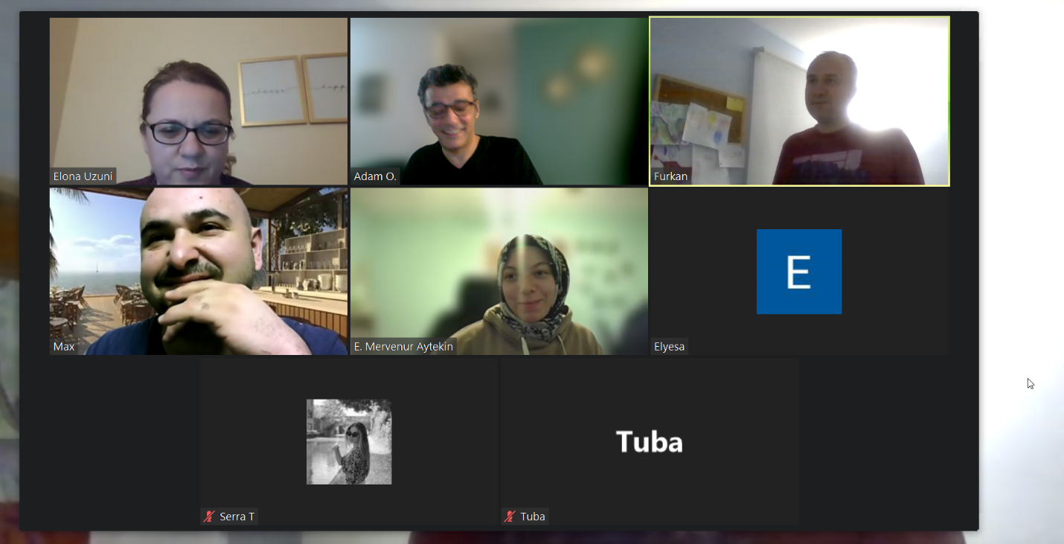

List <String> cars = new List <String>();

cars.add ('Toyota');

cars.add ('Lexus');

cars.add ('KIA');

cars.add ('Tesla');

System.debug(cars);

System.debug(cars.size());

System.debug(cars.get(1));

System.debug(cars.indexof('Tesla'));

cars.set(1, 'Mercedes');

System.debug(cars);

cars.remove(1);

System.debug(cars);

cars.clear();

System.debug(cars);

Set <String> colors = new Set <String>();

colors.add ('blue');

System.debug('pink');

System.debug('green');

System.debug('purple');

System.debug(colors);

System.debug(colors.size());

colors.remove('green');

System.debug(colors);

colors.clear();

System.debug(colors);

Map<String, String> capitalCountry = New Map<String, String>();

capitalCountry.put ('Turkey', 'Ankara');

capitalCountry.put ('USA', 'Washington');

capitalCountry.put ('Germany', 'Berlin');

capitalCountry.put ('Canada', 'Ottawa');

System.debug(capitalCountry);

System.debug(capitalCountry.keyset());

System.debug(capitalCountry.values());

System.debug(capitalCountry.size());

capitalCountry.remove('Turkey');

System.debug(capitalCountry);

Map<String, String> centralCountry = capitalCountry.clone();

System.debug(centralCountry);

System.debug(centralCountry.get('Germany'));

centralCountry.clear();

System.debug(centralCountry);